BAPI

Conversion – BDC – One way data

Cross Applications – Two-way data

BAPI – Business Application Programming Interface

Non-SAP <-> SAP

Remote Enabled Function Call – SE37

SWO2 – Create BAPI

SWO1 – Display Business objects Rep – BO (After attaching RFC to BO, FM becomes BAPI)

System A – FM

System B – Call Function

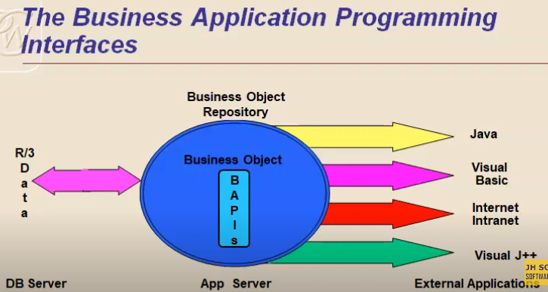

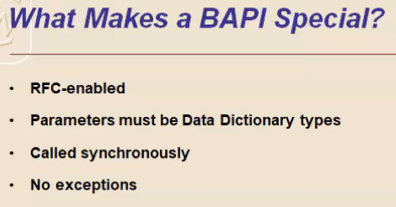

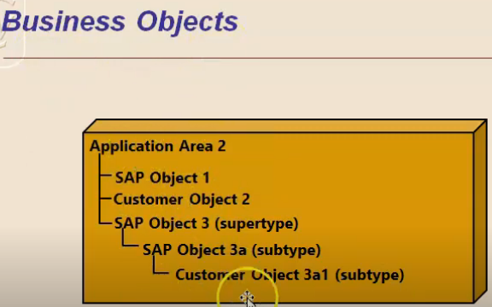

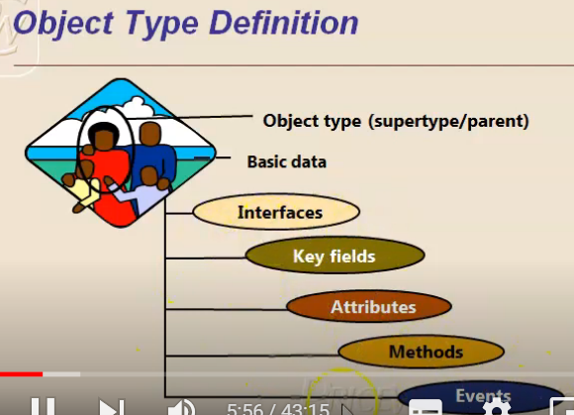

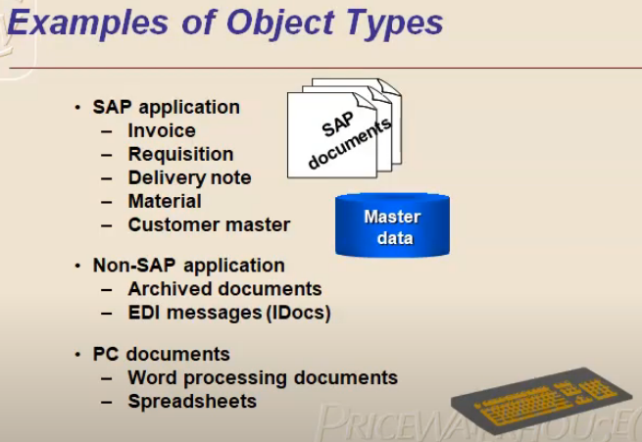

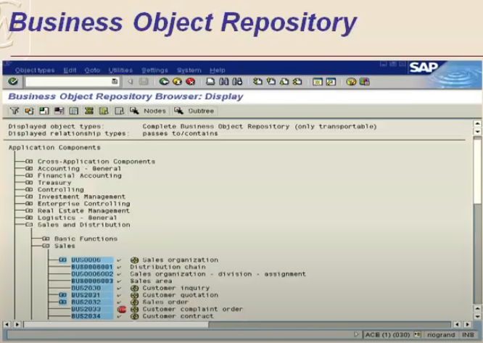

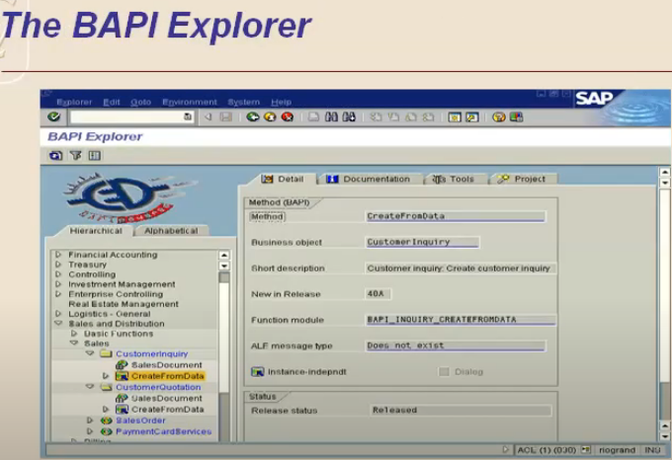

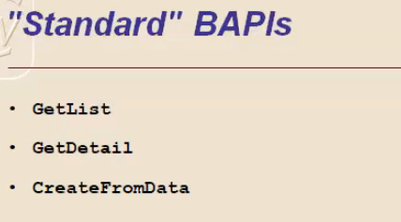

Create BAPI

TCODE – SWO1

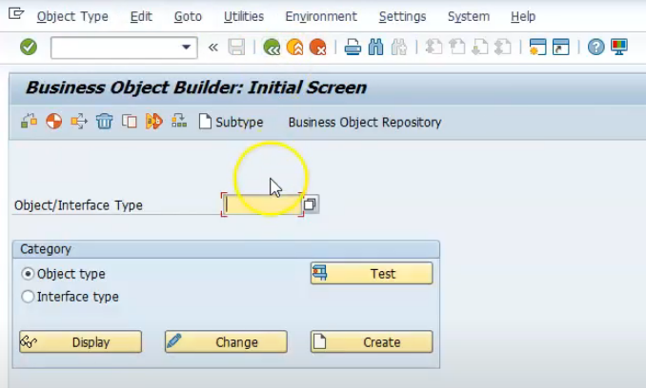

Enter object type

Press Create Button

Only after assigning the remote enables function module to business object it becomes BAPI.

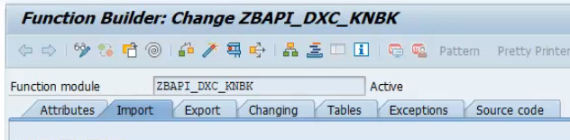

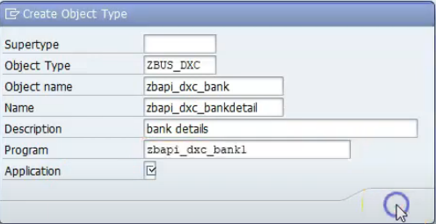

Object Name = Functional Module Name

For now application = cross application

Click ok

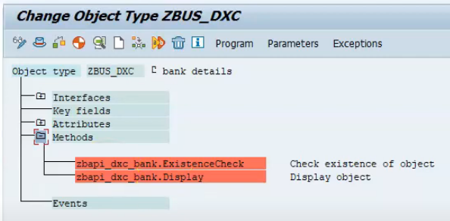

To add FM to methods

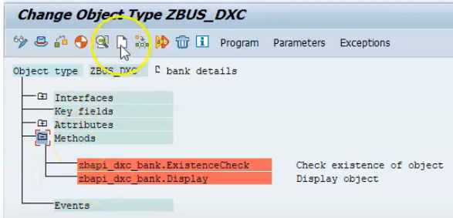

Select methods

Then click on create

Enter FM name

OR

Select method

Go to utilities -> API Methods -> Add method

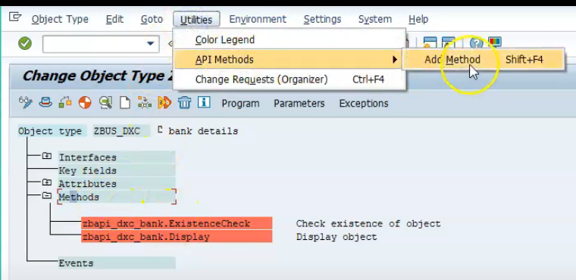

Enter FM name

Click Ok

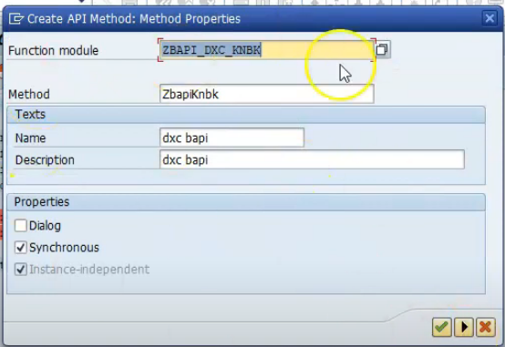

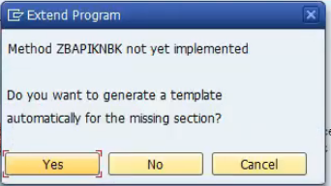

Click yes

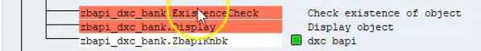

Green color – success

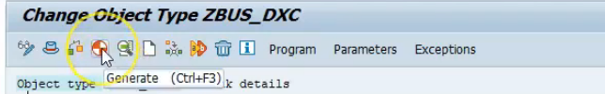

Then click on generate

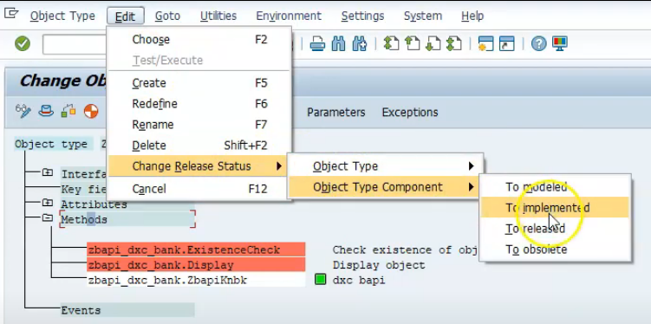

Now change the release status of object type component to implemented, then to released

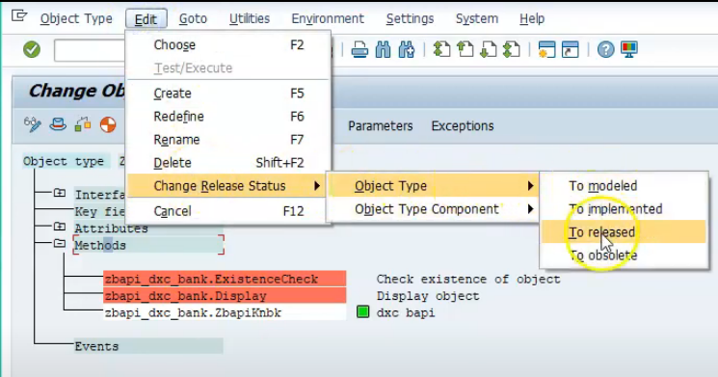

Also change the release status of object type to implemented, then to released

